Design Document

G00358931-Robert Donnelly

Procedural Project

1. This Program begins with prompting the user for a password. The username and password the user must enter are hard coded as “user1” for username and “pass1” for password. I used a While loop that will only exit when the user enters the correct username and password which will set the access int to 0 and exit the loop.

I found out how to replace the user’s password input with a \* at

https://www.geeksforgeeks.org/print-in-place-of-characters-for-reading-passwords-in-c/

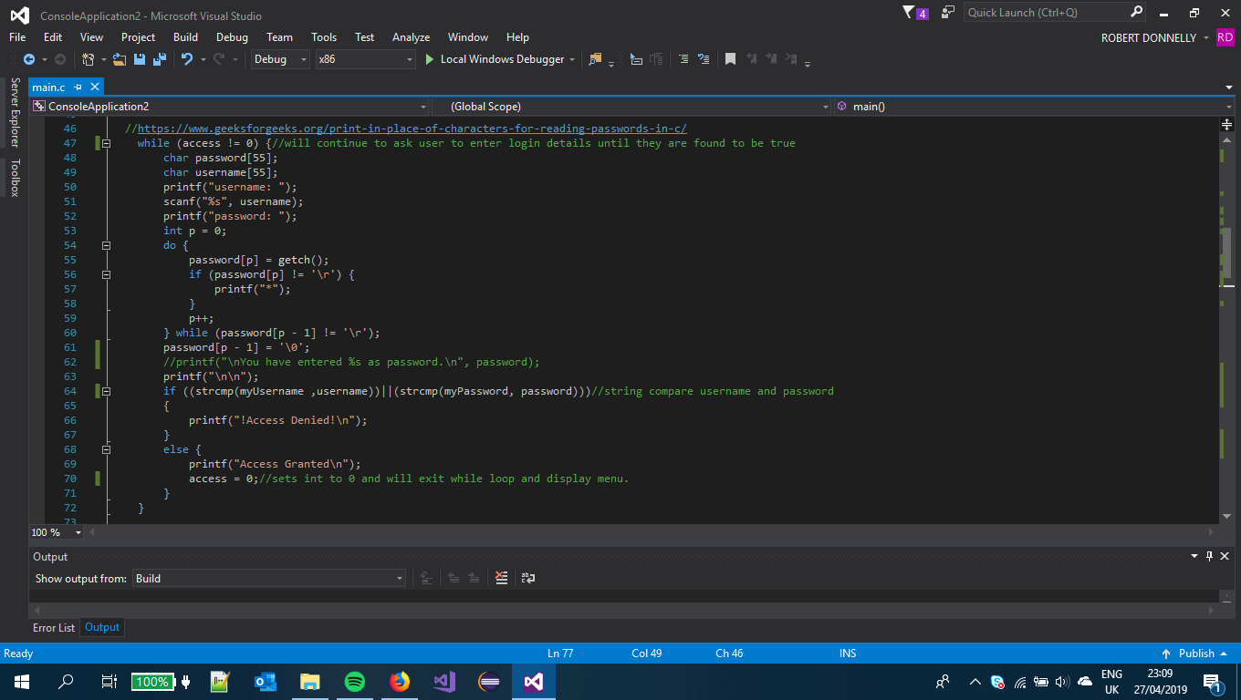

1. The user is then brought into a simple menu Using if statements that asks them to enter a number between 1 and 8. If they don’t enter a number between 1-8, they are asked to enter again.

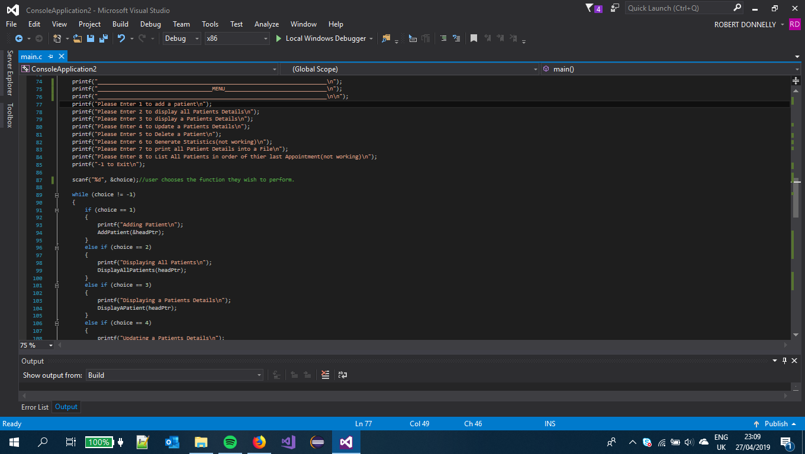

1. if the user selects 1 they are asked to enter the PPS number of patient which is an integer. I use an if statement which calls the searchForPPS function that searches through the linked list to see if the PPS number entered already exists.

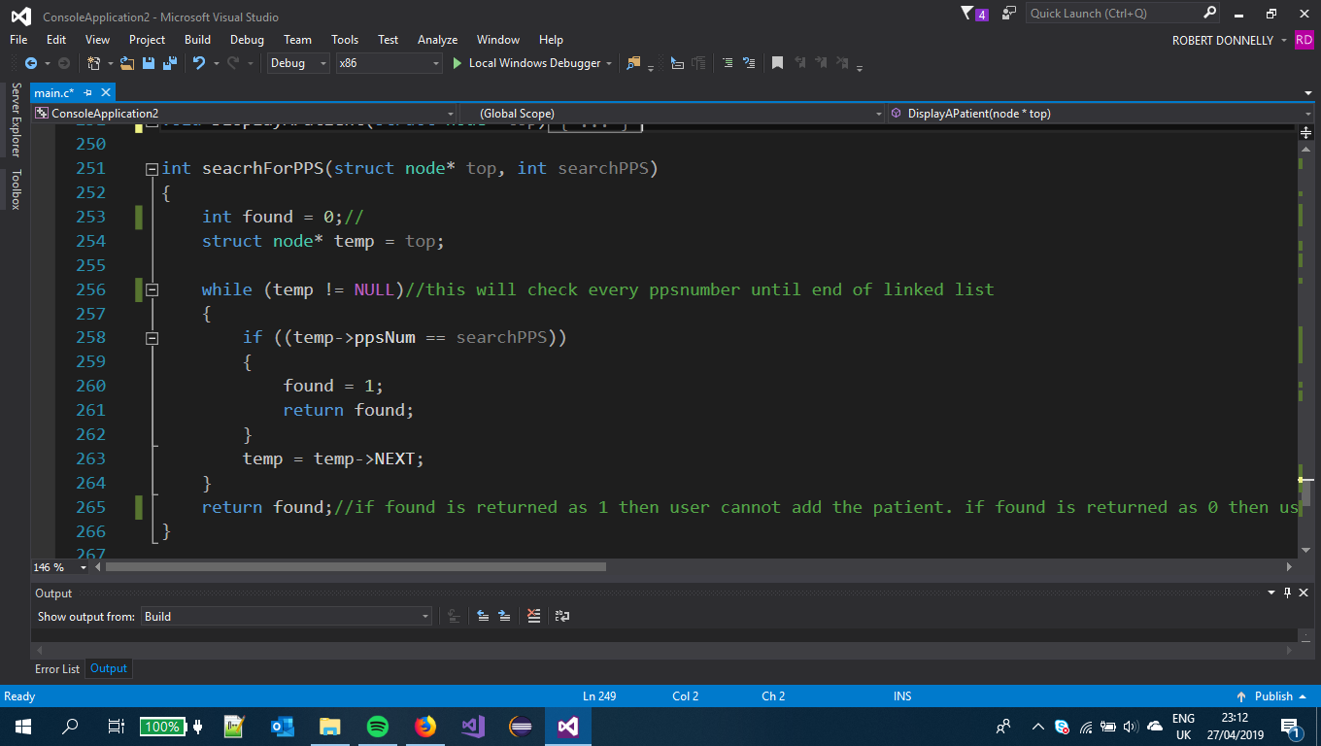

If the function returns a 1 then the user is told that the PPS already exists If not then we continue to assign the node(newNode) its values.

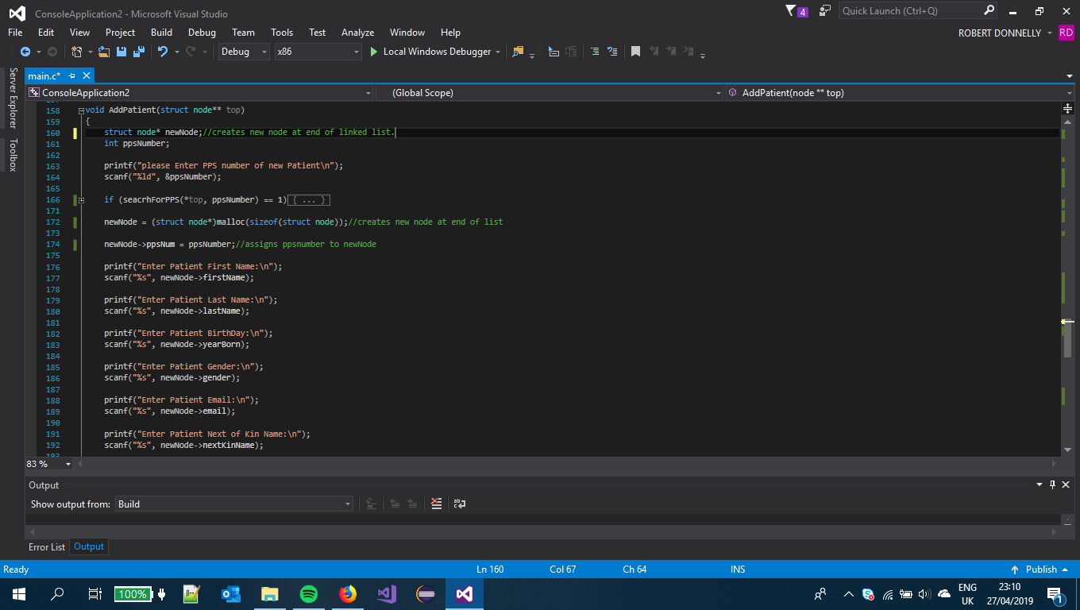

1. if the user chooses option 2 then the DisplayAllPatients function is ran with the headptr parameter. The temp begins at the first node of linked list and a while statement is ran until it is null (end of list). In the while loop the temp (address of node) will print out all the variables In the node and then move to the NEXT node until its NULL.

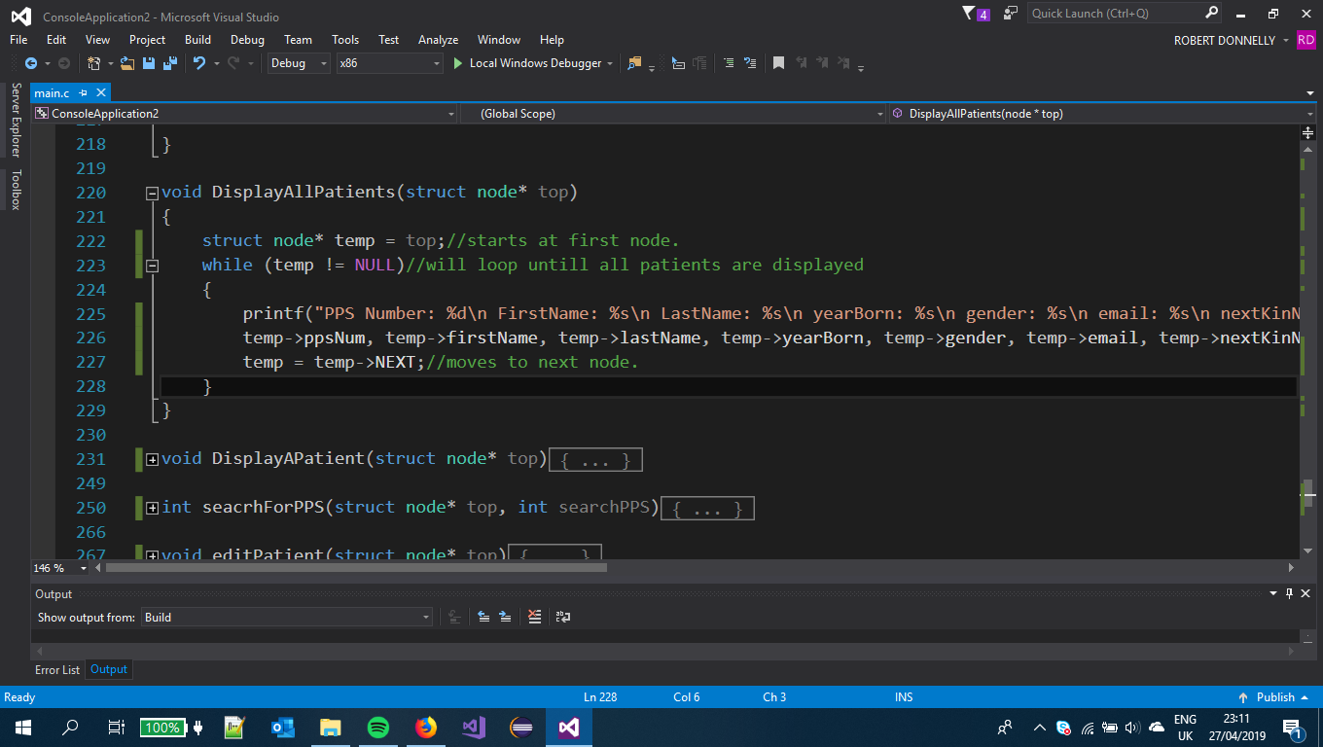

1. If the user selects 3 then they can enter the PPS Number of the patient they wish to display. I use a while statement to loop through all the nodes in the linked list until a matching PPS number is found. Then that node(temp) is printed out and function returns to menu. when temp = Null the user is told the pps number does not exist.

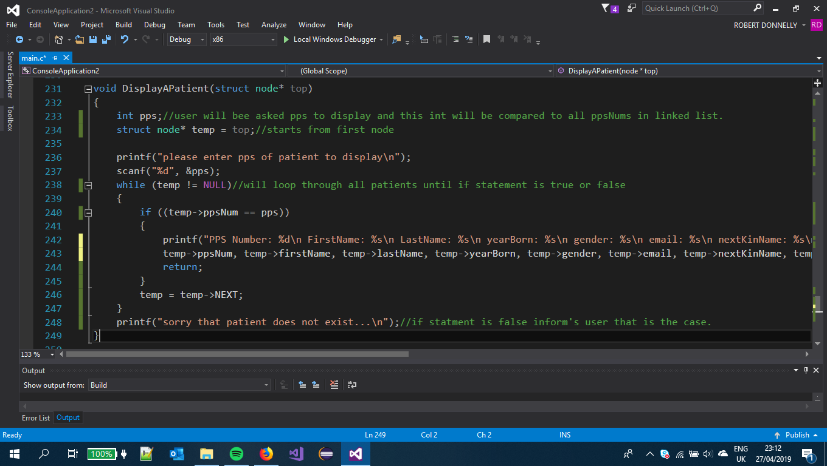

1. If user Selects 4 in the menu, they are asked to enter pps Number of the patient they want to update. Similar to the displayAPatient function I use a while to loop through the linked list. If pps number is a match user can assign the new values to the node, if newNode=NULL then the user is told the pps number doesn’t exist.

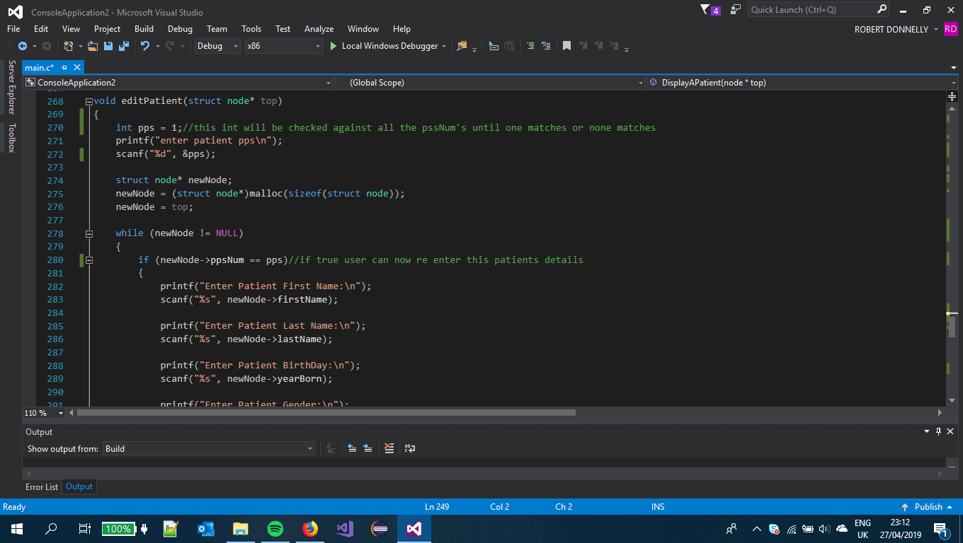

1. If the user enters 5 the user is asked the pps number of the patient to be deleted and the deletePatient function is called with the &headptr and int position which represents the pps number as its parameters. The function will loop through the linked list while the PPS number is not equal to the nodes PPS number:

“while (temp != NULL && temp->ppsNum != position) “.

if the loop reaches the point where the temp is null then it informs the user the pps doesn’t exits and returns them to the menu to try again. If the while loop exits and the temp is not null then the node is removed from the linked list and the temp is freed.

I learned how to do this function at:

//https://www.geeksforgeeks.org/linked-list-set-3-deleting-node/

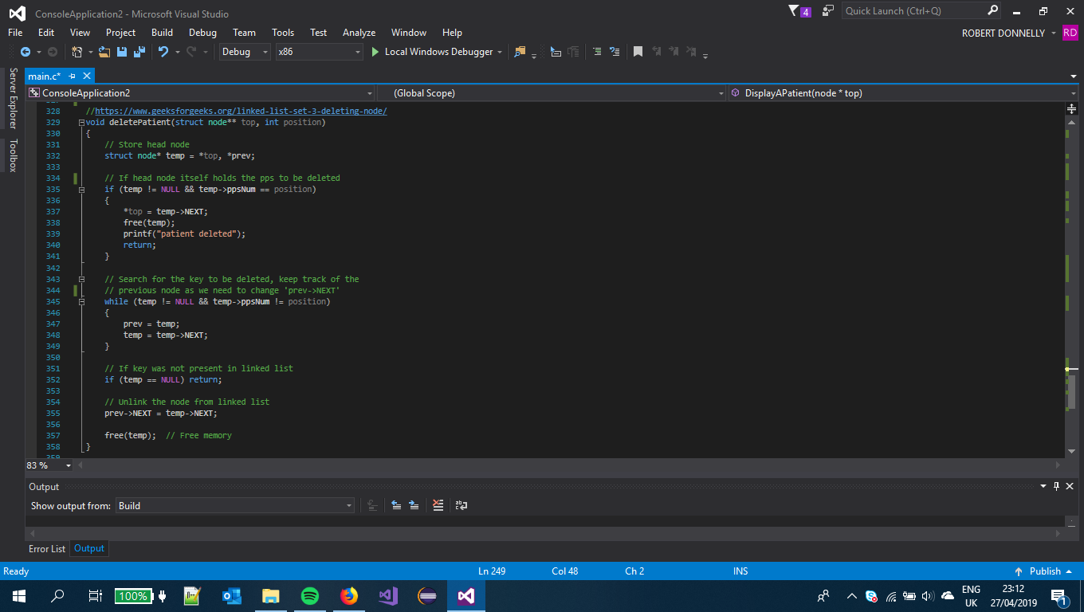

1. If the user Enters 7 then the writeFile Function is called with the headPtr and FILE\* “report” passed as its parameters. The While statement will fprintf the details of the patient at the temp address into the file then move to the next address and repeat until the temp is NULL. The while loop will exit and then close the file and inform the user of what has happened.

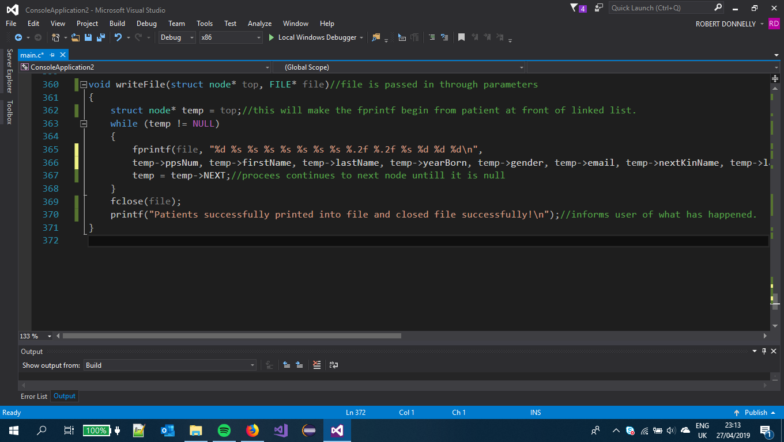

1. Functions 6 & 8 perform no nothing but printf’s telling the user that nothing happened. I do not have these functions in my project because I didn’t get that far in time.

This concludes my design document. I hope it has been of satisfaction and helped you understand my code and how I put my project together.

Robert Donnelly G00358931